**Configuration guide for API hoteles**

**Database laboratory**

The lab was developed completely with PHP, under the framework of Laravel version 5.7, which is the last version available, in order to use this version is needed a PHP and a Composer version equal or superior to 7.1.3 in your computer.

Our group recommend using XAMPP to help you set up the local server, this is due to we developed our project using this source.

When running XAMPP or any other local server, you must make sure that both the ports and the Apache are in 80 or 433 and the same with MySQL in 3306, as shown in the image below.

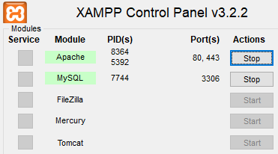

To set up the database, the following steps must be followed in order to have a correct performance:

1. Open PHPMyAdmin.
2. In the menu on the left side, you must click in the button “Nueva”, that will create a new database.
3. The name must be “api_lab_db”, then click on “Crear”.
4. Inside the database, look for the Navbar from the top and click on “Importar”.
5. in “Seleccionar archivo” look for “api_lab_db.sql” that you downloaded.
6. go to the end of the page and click on “Continuar”.
7. All set.

Finally, when starting the API, first you must turn on the Apache server of preference together with MySQL database manager, then the server that Laravel uses in order function. For this, you must follow the next steps:

1. Go inside the "API_Lab" folder by Windows Commands
2. Write the next command: “php artisan serve”
3. if everything was correctly done, you should obtain the same result as the image below.

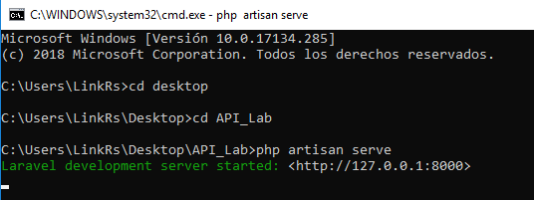

To enter to Laravel, you must do it for localhost:8000 o 127.0.0.1:8000, and doc can be seen on localhost:8000/doc